Article type (eg. Article, review, communications, editorial)

Research on Solar Simulation System for Testing Solar Radiation Measuring Instruments
Firstname Lastname¹, Firstname Lastname² and Firstname Lastname^{2, *}
¹ Department/Division, Institution/Organization, City, State/Province, Country
² (Optional for multiple affiliations) Second Department/Division, Second Institution/Organization, City, State/Province, Country
* Corresponding author email: e-mail@e-mail.com

Copyright: © 2024 by the authors. This article is licensed under a Creative Commons Attribution 4.0 International License (CC BY) license (https://creativecommons.org/licenses/by/4.0/).
Abstract: Your abstract should concisely summarize the main objectives, methods, results, and conclusions of your study. It should be clear, precise, and self-contained, typically not exceeding 250 words. Avoid using abbreviations and citations in this section. Begin with a brief introduction to the problem or research question addressed, followed by a succinct description of the research methodology and techniques used. Then, summarize the key findings and their significance. Conclude with a statement about the implications of the findings or potential future directions for research. Remember, the abstract should be comprehensible to a broad audience, so technical jargon should be minimized.
Keywords: keyword 1; keyword 2; keyword 3 (no more than 5 keywords)

Citation：

1 Introduction
The Introduction should provide a concise and clear background to the research topic, highlighting the problem or question being addressed. It should briefly summarize relevant existing literature to contextualize the research within the field, clearly identifying the gap or need the study aims to fill or address. The introduction must culminate in stating the specific objectives or hypotheses of the current study. This section sets the stage for the research, drawing the reader’s attention to why this study is important, novel, and how it contributes to the field.
References should be numbered in order of appearance and indicated by a numeral or numerals in square brackets—e.g., [1] or [2,3], or [4–6].

2 Materials and Methods

2.1 Sub Section
3.1.1. Subsubsection
This section should provide a detailed and clear description of the experimental design, materials used, and methodologies employed in the research. Authors should include information on the study's setting, types of materials or data used, and a step-by-step explanation of the procedures and techniques applied. This description must be thorough enough to allow other researchers to replicate the study. It's essential to specify any equipment or software used, including model numbers and manufacturers, if relevant. When applicable, authors should mention ethical approvals, including details of any oversight committees, and informed consent for studies involving human subjects. The Materials and Methods section should end with a description of the statistical methods used for data analysis, ensuring they are appropriate for the type of data collected.
* Figures and the tables included should be placed next to the relevant text in the manuscript. The texts in figures, images, and artworks should be Arial. And their sizes should be large enough to be read.

3 Results
The Results section should present the findings of the study clearly and concisely, focusing on the data obtained from the research without interpretation or discussion. Authors should structure this section in a logical sequence, often mirroring the order in which the experiments were conducted or following the sequence of research questions or hypotheses tested.

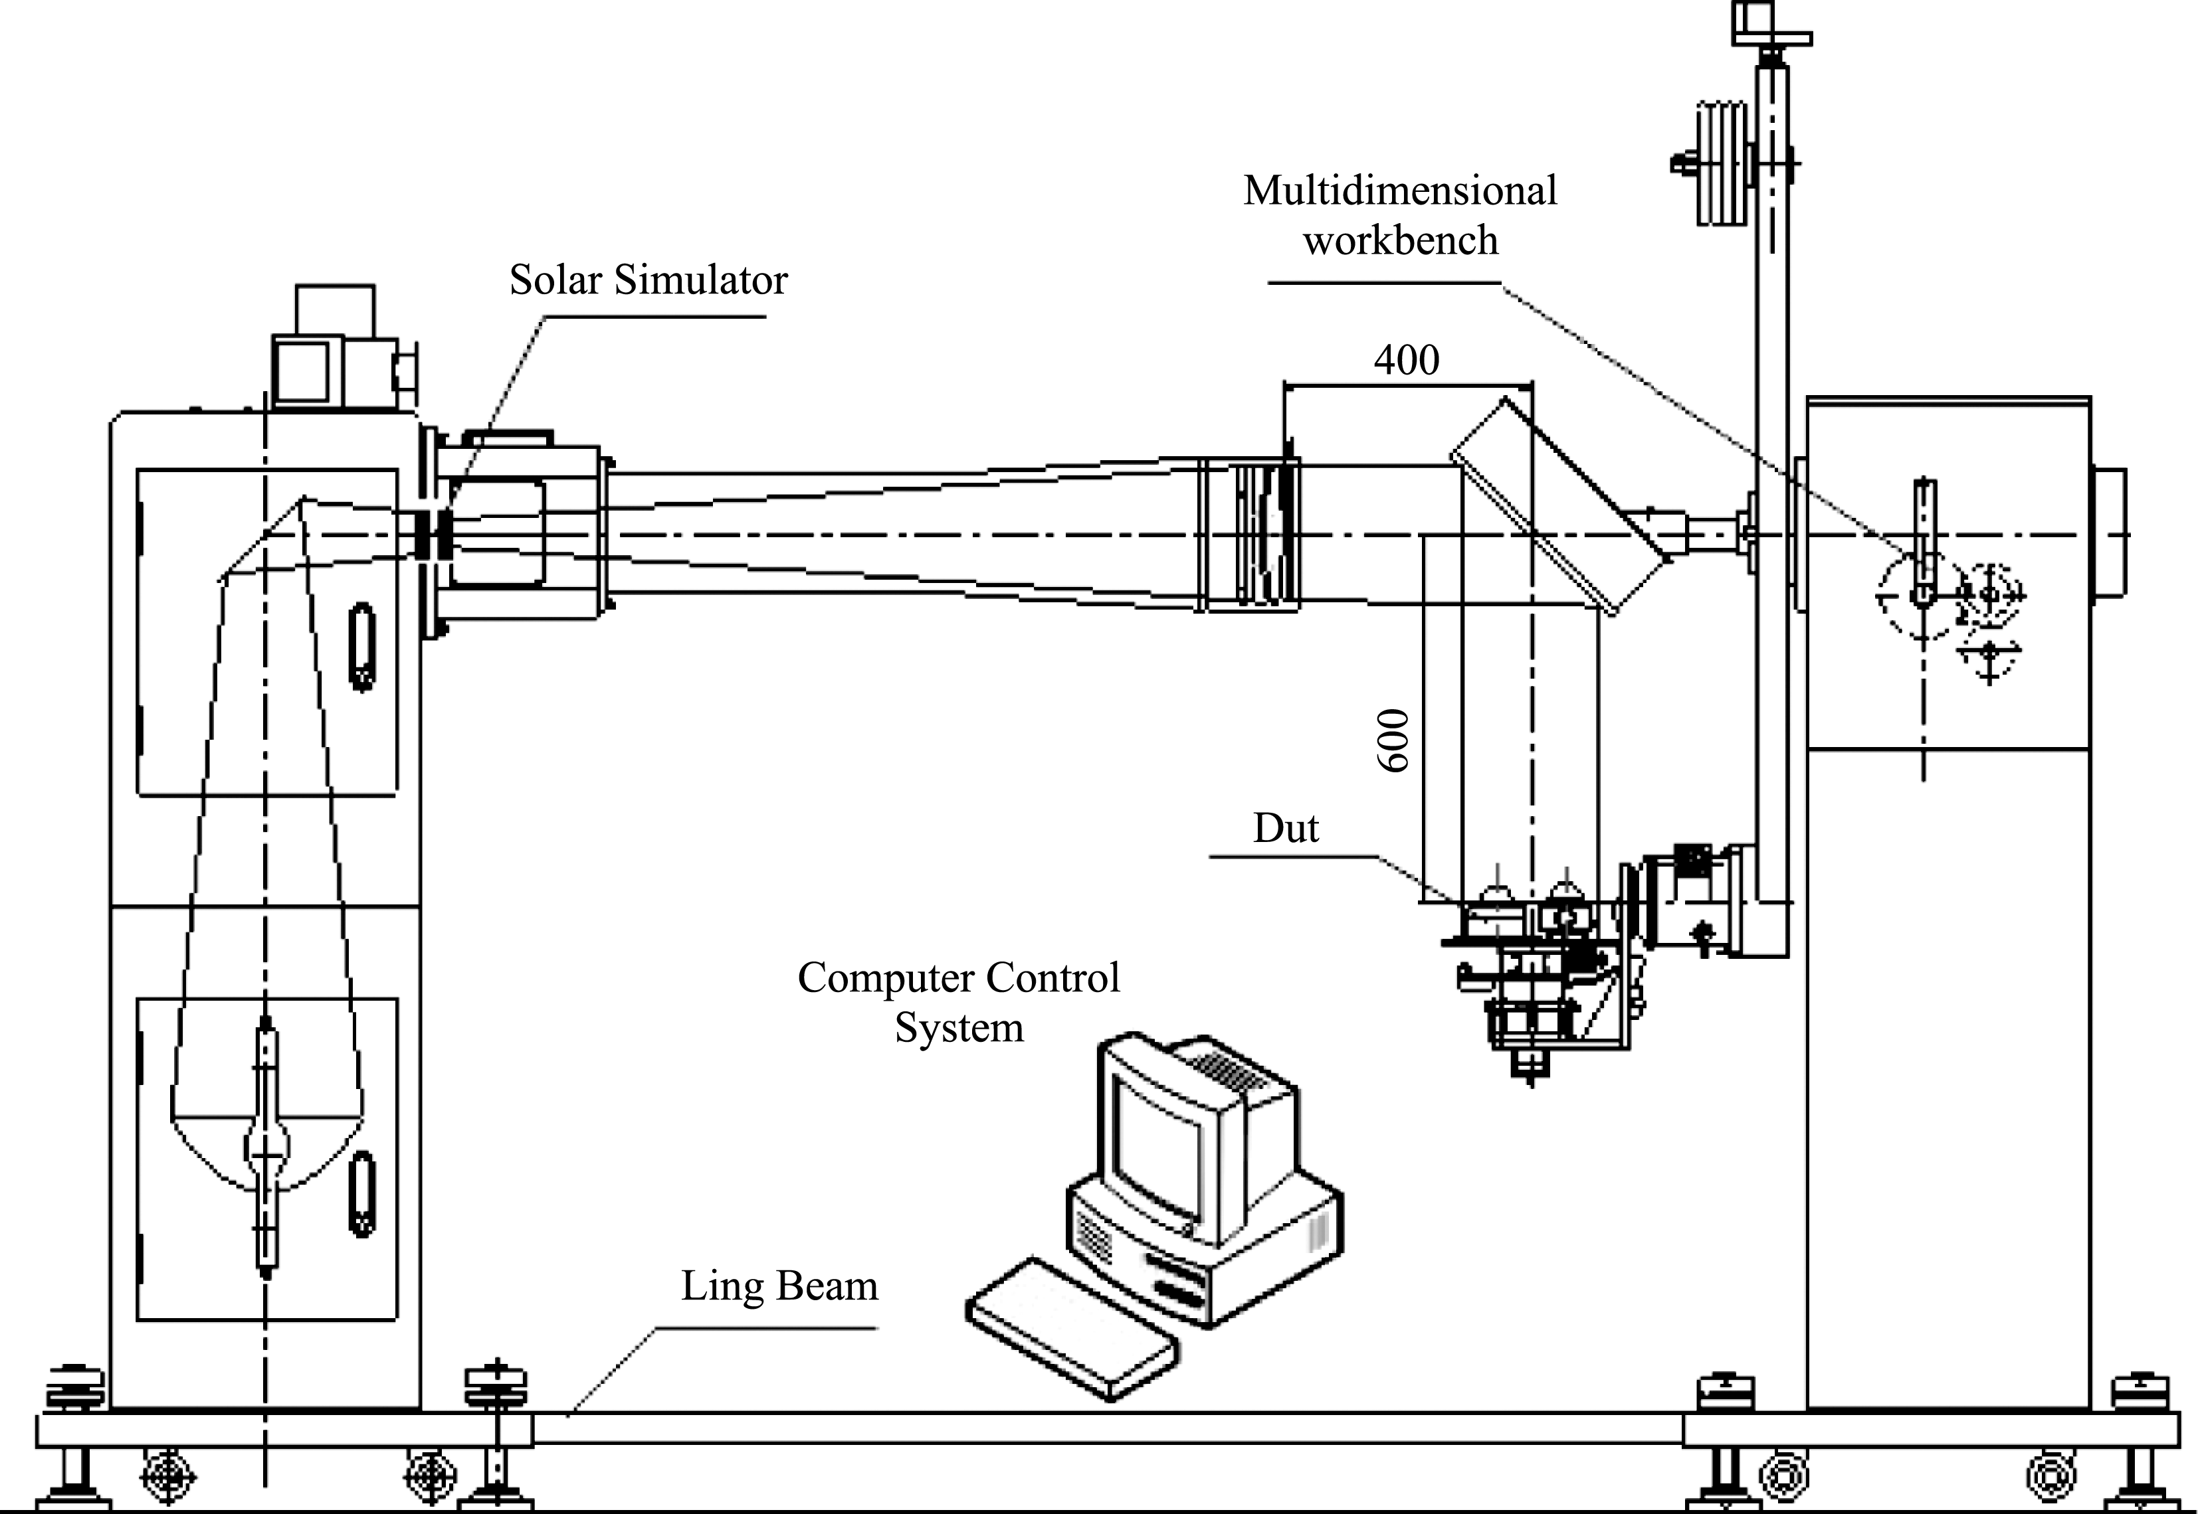

Fig.1 (Sample)

Table 1 (Sample)
No. | Indoor | Outdoor | Relative Error (%)
11# | 9.422 | 9.385 | 0.4
14# | 9.554 | 9.534 | 0.2
7# | 9.694 | 9.621 | 0.8
6# | 9.328 | 9.303 | 0.3

4 Discussion
Authors should discuss the results and how they can be interpreted from the per-spective of previous studies and of the working hypotheses. The findings and their im-plications should be discussed in the broadest context possible. Future research direc-tions may also be highlighted.

5 Conclusion
This section is not mandatory but can be added to the manuscript if the discussion is unusually long or complex.

Author Contributions:
A breakdown of the specific contributions of each author. This might include who conducted the research, the suggested roles are listed: Conceptualization; Data curation; Formal analysis; Funding acquisition; Investigation; Methodology; Project administration; Resources; Software; Supervision; Validation; Visualization; Roles/Writing - original draft; and Writing - review & editing. Authors are encouraged to identify the roles that apply to their contribution realistically and accurately, ensuring a fair and transparent acknowledgment of each member's involvement in the research.

Acknowledgments:
This section acknowledges any significant contributions from individuals, organizations, or institutions that do not justify authorship. It’s also used to recognize any non-financial support.

Funding Information:
Please add: “This research received no external funding” or “This research was funded by NAME OF FUNDER, grant number XXX”. (Details of any financial support received for the research, including grant numbers and the names of funding organizations. )

Data Availability:
The authors declare that the main data supporting the findings of this study are available within the paper and its Supplementary Information files. (A statement regarding where the data supporting the findings of the study can be found. If the data is not publicly available, the reasons should be stated. For engineering journals, this might include datasets, software, or other materials used in the research.)

Conflict of Interest:
The authors declare no competing interests.

Dates:
Received 17 July 2023; Accepted 17 December 2023;
Published online 28 December 2023

References
- Author1, A., & Author2, B. (Year). Title of the article [J]. Journal Name, Volume(Issue), Page range. doi:DOI
- Author3, C. D., Author4, E. F., & Author5, G. H. (Year). Title of another article. In Editor1, I. J., & Editor2, K. L. (Eds.), Title of the Book or Conference Proceedings, Pages range. Publisher Name. ISBN
- Author6, M. N. (Year). Title of the Book. Publisher Name. ISBN
- Author7, O., Author8, P. Q., & Author9, R. S. (Year). Title of the article. Journal Name, Volume(Issue), Page range. URL if available

